Research Ethics Board
Fredericton NB E3B 5G3

January 30, 2019

Dear Dr. Baldwin,

RE: Ethics research proposal: REB #2014-25

Title: Spiritualty in the Modern Age

The Research Ethics Board at St. Thomas University has reviewed your file and grants approval for the title change as above. Please note the following regarding all research that has been granted ethical approval by the REB:

1. If there are any substantial changes to the research plan or research protocol the Chair of the REB must be promptly notified.
2. If the project continues after one year, please submit a completed "Annual/Final Report" form to the REB (available on the REB website).
3. When the project has been completed please notify the Chair of the REB by completing the "Annual/Final Report" form (available on the REB website).

Please also ensure that you quote your REB certificate number on all public documents associated with this research (e.g., recruiting advertisements, letter of informed consent etc).

If you have any further queries, please contact me (phone 460-0347 or email oregan@stu.ca@stu.ca or Danielle Connell in the Office of Research Services (452-0647 or email reb@stu.ca).

Best wishes in your research.

Yours Sincerely,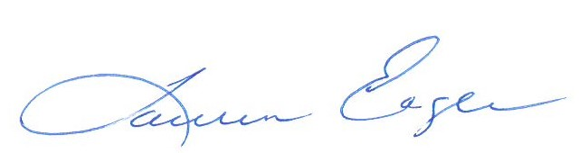Lauren Eagle
REB Coordinator

cc: Office of Research Services

